# **Introduction**

# 

# **IMPORTANT:** DO NOT RUN THE QUICK-START INSIDE OF THE GITHUB FOLDER.

* 1. If you would like to run the quick-start guide you may want to create a separate folder locally. If you build the quick-start inside of the GitHub folder all of the files will be added to the ReadTheDocs website

# [Getting started with Sphinx](https://quick-sphinx-tutorial.readthedocs.io/en/latest/firststeps.html)

* 1. I have tried to use both a conda environment and also local python and have found using conda to be easier because the extensions used in the website often have updates which cause errors in other packages
     1. You do not need to create separate conda environments for the different branches but can, if you would like to
     2. If you have a case where one extension is causing issues in another and it is one that you would only like to use in one branch then I would suggest creating different branches
        1. I have not encountered this yet as I use the same extensions for both branches
  2. [More information on miniconda3 and sphinx installation](https://obm.physics.metu.edu.tr/node/65)
  3. [More information on local installation](https://www.sphinx-doc.org/en/master/usage/installation.html)
  4. I have had issues (multiple times) in the past where my conda environment will create issues with VSCode, the best solution that I have found is to uninstall and reinstall the environment (you’ll have to do this manually). Other solutions have not worked for me
     1. One common issue that I have encountered when there have been extension updates is: 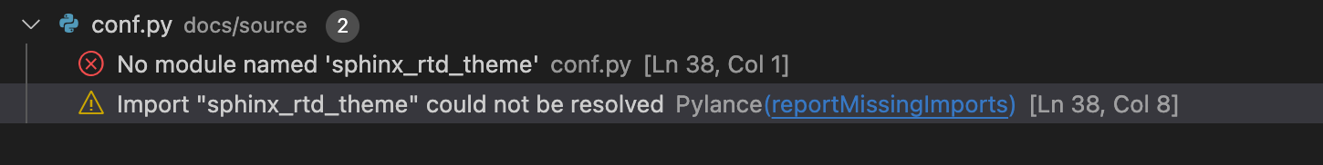
        1. There is no working solution that I have found for this issue – in this case I will re-install my sphinx environment/extensions and use a new conda environment
  5. All extensions can be found here: $ wget -O - https://pypi.org/simple/ | grep -i sphinx

1. Once you have created the sphinx environment + installed all of the required extensions (you may want to review the list of packages that are listed in the conf.py file to see if you have missed any)
2. If you use VSCode then you will have to make sure that the python path is the same as the one to your conda environment/that you are in your conda environment linked with sphinx/the extensions
   1. It is also possible not to use VSCode and simply edit the .rst files in a text editor
   2. In this case you will have to build the files (if you’d like to see them locally) or you will have to push the changes and update the ReadTheDocs website
   3. If you are using VSCode then you will not need to build the documents manually, and will be able to see them as you edit.
      1. Click on the magnifying glass  to see the documents
         1. Esbonio may take some time to build the documents, especially if this is the first time that you are building them or have closed the documents and are now re-opening/rebuilding the documents
         2. Suggestion: If you plan on making many changes to the files over the course of a few days I would recommend leaving the application (VSCode) open and activating/deactivating the conda environment as needed
3. Once you have installed the conda environment and extensions, in VSCode you may want to use [Esbonio language server](https://github.com/swyddfa/esbonio) (this has been the easiest way to create Sphinx docs, for me). *See image for what the backend looks like* 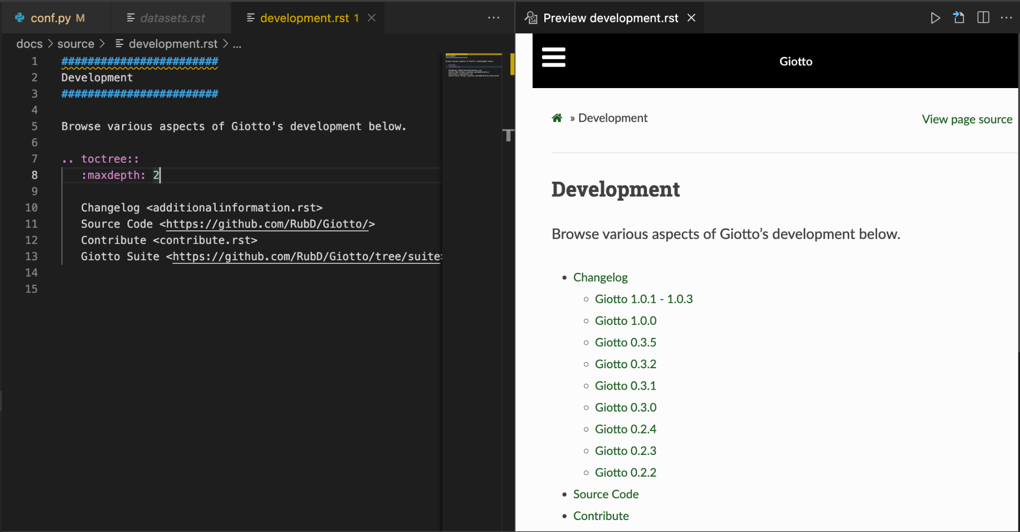
   1. There is also an rst language server that I have used in the past but it seems that most people recommend using Esbonio and therefore using the rst language server may cause some issues
4. Errors on VSCode
   1. There will be many errors or warnings in the PROBLEMS section, you may ignore the warnings (or can fix them if you’d like).
   2. Some of the most common warning errors that I have encountered are ‘duplicate label’ warnings. These do not cause issues and I have tried to create exceptions for them not to come up but have been unsuccessful in getting rid of all of them
   3. Most errors must be fixed – some of the most common ones will be related to either mislabeling something or forgetting <> or ‘’ symbols when creating links
      1. *Preferred:* If there are many of these errors the website may not build (check the ReadTheDocs website to see what the exact errors are if there are build errors)
      2. *Alternative*: Another way to check is to build the files locally (outside of VSCode)
   4. ‘Document isnt included in any toctree’ warning – must be fixed
      1. This means that your document is not linked to any toctrees and is “free floating.” If you do not want to include the document then you’ll need to delete it. Otherwise you will need to link the document (via :doc:, :ref: or .._ ) to another document or include it in a toctree
      2. Each time that you create a new .rst file you will have to manually add it to a toc tree or link it to another document
5. Remember to push changes to GitHub (before switching branches). To do so in VSCode click on the fork icon on the bottom left . You can also push/pull changes (you may want to do this before updating files if multiple people have been editing)

**Some File Structure**

**\*if you change the name of a directory – you must manually go into each file where that directory appears and change the name\***

* Docs – sphinx project
  + Source – the files you edit
    - _build – automatically created
    - Subsections
      * Images
        + Other – dataset images are here
  + Build – automatically created

# **Sphinx Tips w/Links:**

1. [Information on the button-link directive](https://sphinx-design.readthedocs.io/en/latest/badges_buttons.html#buttons)
2. In order to get a package to register add it to the requirements.txt file
3. [Another Cheat Sheet](https://docs.typo3.org/m/typo3/docs-how-to-document/main/en-us/WritingReST/CheatSheet.html)
4. [Spell Checker](https://sphinxcontrib-spelling.readthedocs.io/en/latest/install.html) (requires [this](https://pyenchant.github.io/pyenchant/install.html))
5. [Information on having multiple branches](https://stackoverflow.com/questions/65757315/readthedocs-site-with-2-long-term-version-branches)
6. [Sphinx Extensions Documentation](https://sphinx-extensions.readthedocs.io/en/latest/)
7. [GitHub shields](https://sphinx-toolbox.readthedocs.io/en/stable/extensions/shields.html)
8. Images
   1. All images must be .png files – all others have caused a fatal build error
      1. I have tried changing the configuration of the .yaml file to include .svg files but was not able to find a work around that did not cause a fatal build error
9. [Card-Carousel](https://sphinx-design.readthedocs.io/en/furo-theme/cards.html)
   1. When creating a card-carousel keep the # (.. card-carousel:: #) the same for all of the ones on the page – if the number is changed then the ratio (size) of the images changes as well.
   2. I prefer using this when linking to other pages (i.e. for datasets) because it is less likely to cause errors (i.e. not linking)
10. [Configuration.yaml](https://docs.readthedocs.io/en/latest/config-file/v2.html#build)
11. Creating dataset examples
    1. When you’re creating these examples it’s possible to take the code directly from the .Rmd file (the file must be in the repo/branch for which the website page is being built). – You can do this using .. literal:: it will copy all of the codes from the lines which you specify but if someone changes the code and the lines shift sphinx will not know and you will have to manually update
    2. Another option is to copy/paste the code using .. code-block
       1. This is how all of the datasets are currently created because I found it easier (more time consuming) because the .Rmd files were often moved or would be removed from the repo
          1. Because the files were not created by me it was harder to find all of the files, since many people are working on Giotto.
       2. The best option would be to have the person who created the example code copy/paste the code when they create a new dataset example into an .rst file (or let someone who is editing the website know that there is a new vignette).

OUTSTANDING TODO’s